Binary Tree
A tree whose elements have at most 2 children.
Trees are hierarchical data structures.
The topmost node is called root of the tree.
The elements that are directly under an element are called its children.
Why Trees?
To store information that naturally forms a hierarchy. For example, the file system on a computer
Trees (with some ordering e.g., BST) provide moderate access/search (quicker than Linked List and slower than arrays).
Trees provide moderate insertion/deletion (quicker than Arrays and slower than Unordered Linked Lists).
Main applications of trees include:
1. Manipulate hierarchical data.
2. Make information easy to search (see tree traversal).
3. Manipulate sorted lists of data.
4. As a workflow for compositing digital images for visual effects.
5. Router algorithms
6. Form of a multi-stage decision-making (see business chess).
Binary Tree Properties:
- The maximum number of nodes at level ‘l’ of a binary tree is 2l.
- The Maximum number of nodes in a binary tree of height ‘h’ is 2h – 1.
- In a Binary Tree with N nodes, minimum possible height or the minimum number of levels is? Log2(N+1) ?
- A Binary Tree with L leaves has at least | Log2L? |+ 1 levels
- In Binary tree where every node has 0 or 2 children, the number of leaf nodes is always one more than nodes with two children.
Full Binary Tree A Binary Tree is a full binary tree if every node has 0 or 2 children.
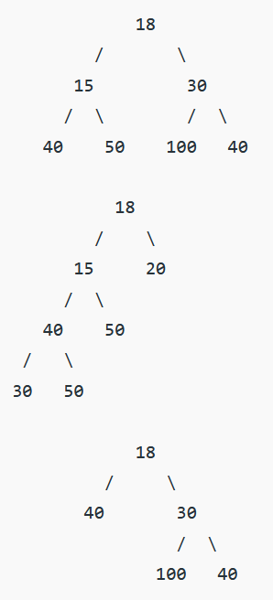
Complete Binary Tree: A Binary Tree is a Complete Binary Tree if all the levels are completely filled except possibly the last level and the last level has all keys as left as possible
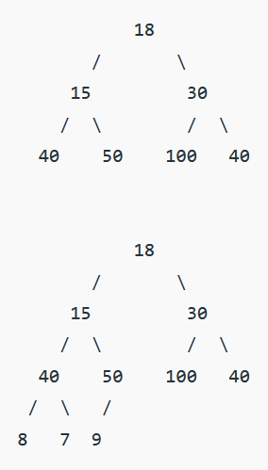
Perfect Binary Tree A Binary tree is a Perfect Binary Tree in which all the internal nodes have two children and all leaf nodes are at the same level.
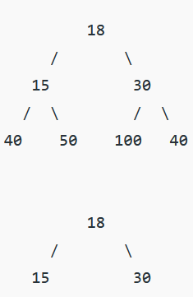
A degenerate (or pathological) tree A Tree where every internal node has one child. Such trees are performance-wise same as linked list.
